TF Physical Check

Taki Guan @ 2019-3-15

TF physical check module is designed only for Sanxiao.

It includes bristle strand count, anchor length and trim height check items. Different hole have different strand count and different M code of bristle also has different standard strand count. Anchor length also has relation with different holes’ size.

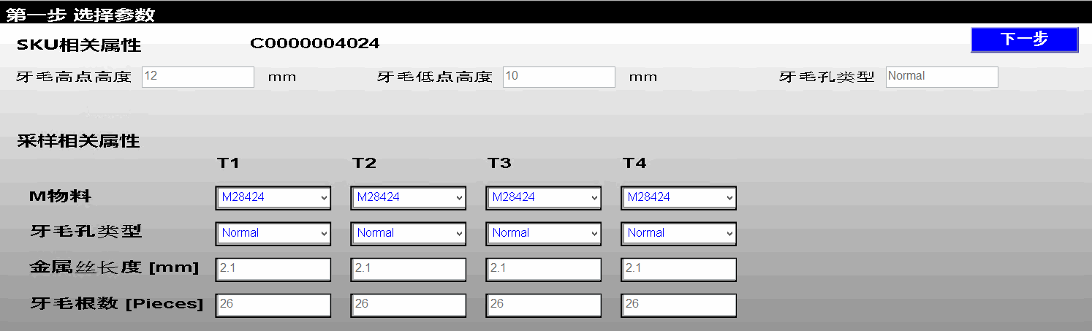

Now TF physical check configuration button is added to admin menu. You can click TF physical check button for configuration.

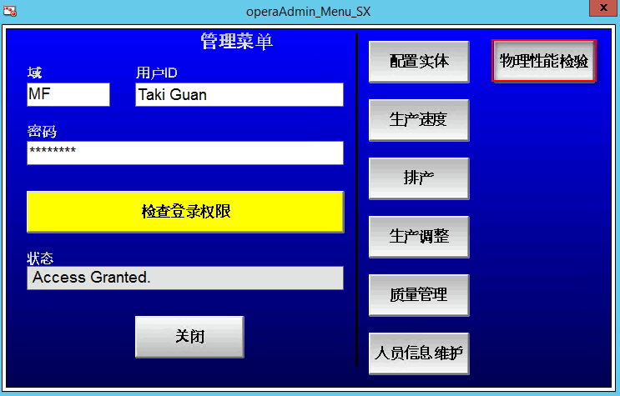

###### 1 Single SKU Maintenance

When we open quality physical check configuration window, we can see two tables. One table locates on top list all SKUs. You can select one SKU then modify trim height directly on the below field.

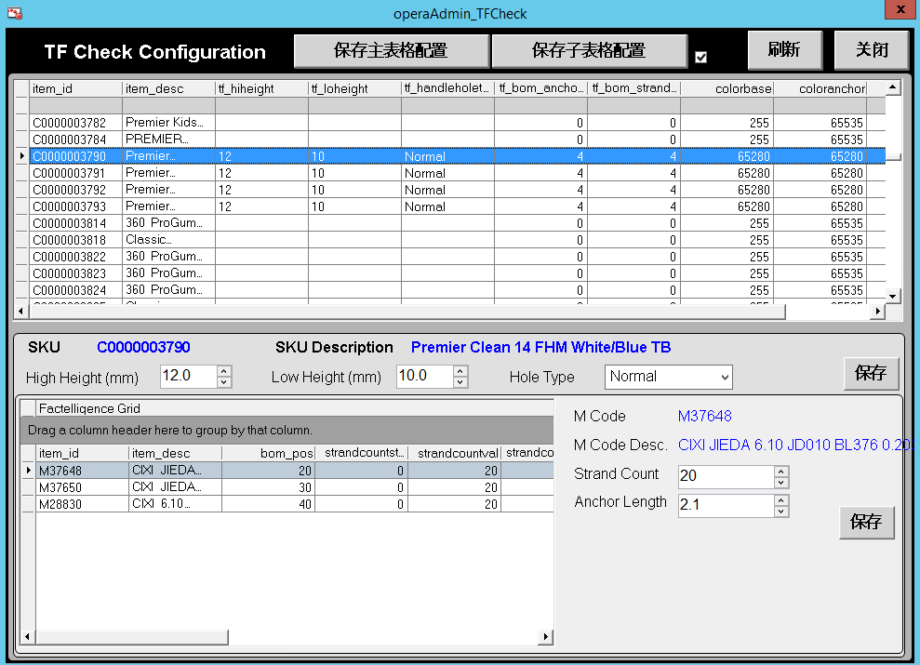

Then you can click the BOM M code one by one to modify strand count and anchor length.

###### 2. Batch SKUs Maintenance

If there are many SKUs need to be modified. We can use Excel export and import function to update parameter.

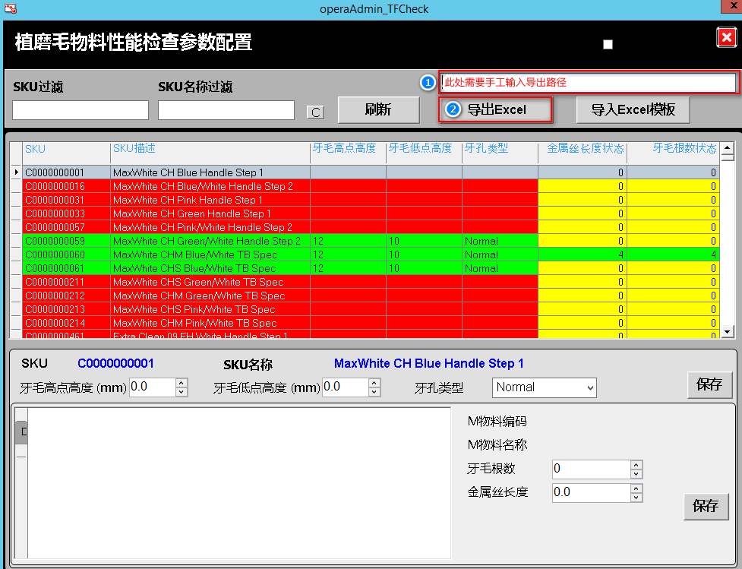

1. Input the specific destination of the export folder in the empty field;
2. Click “Export to Excel” button and wait the completed window appears;

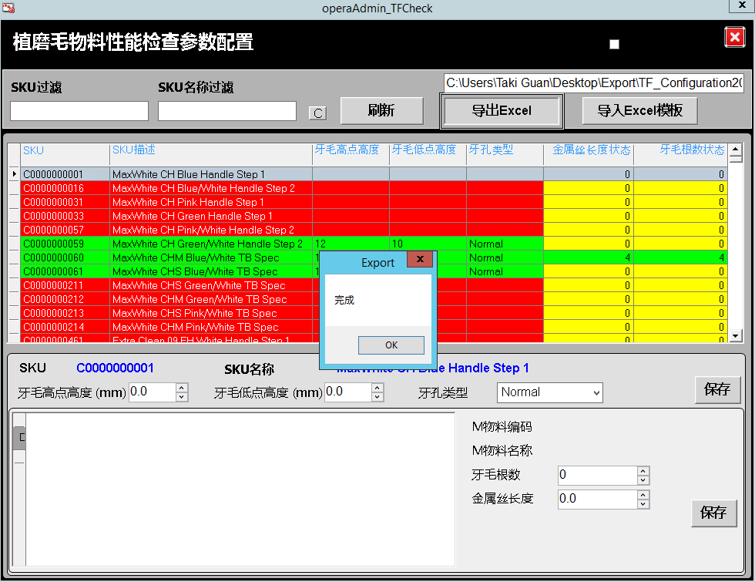

1. Copy this excel document to our computer to open it and edit. Copy it back to replace old one;
2. Click “Import Excel Template” button to import the excel file;
3. Check the master data is updated or not.

###### 3. QM SPEC Definition

There are 5 Characteristics defined for the QM specification of TF physical check.

* TF_HiHeight
* TF_LoHeight
* TF_MCode
* TF_StrandCount
* TF_AnchorLength

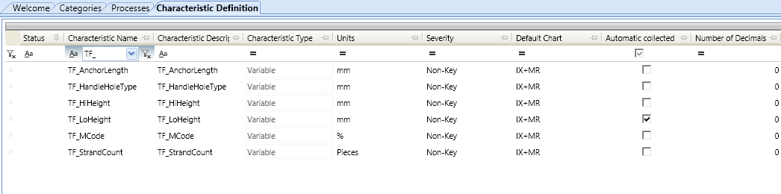

For characteristics TF_HiHeight, TF_LoHeight, TF_StrandCount and TF_AnchorLength, the attribute “TargetValue” should be assigned.

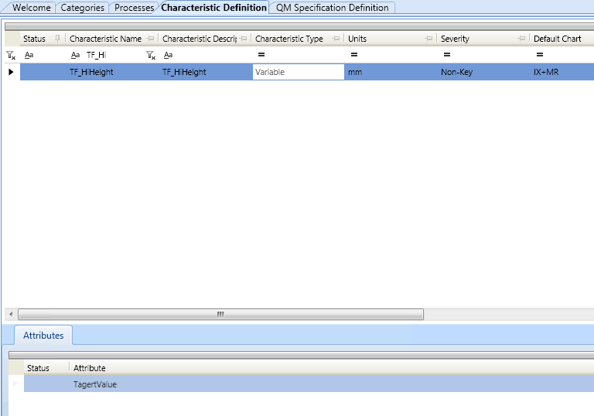

For characteristic TF_MCode, attributes “TF_HandleHoleType”, “TF_MCode”, “TF_StrandCount” and “TF_AnchorLength” should be assigned.

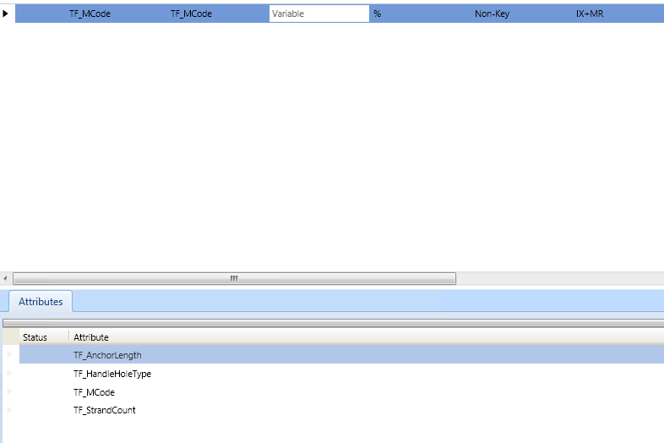

QM specification TF MCode Check is defined which host 5 characteristics.

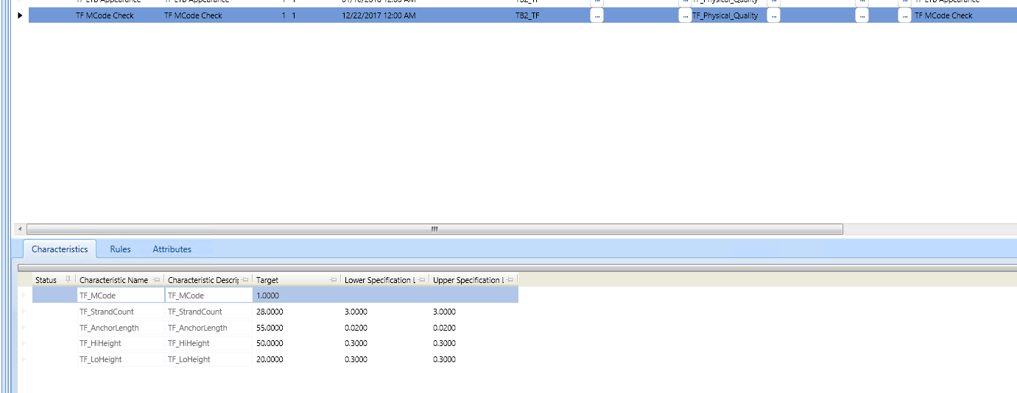

###### 4 QM Object in IDE

Template “$ngsfrQMVarCheck_TF_Check” is created for TF physical check, the value of attribute “Cfg.QM.Graphic_Name” should be set as “OperaQuality_VarChk2Step_SXA”.

